

Primary High Notes Friday 13th March

As we move through a busy and vibrant part of the term, it has been wonderful to see so many opportunities for our pupils to share their talents, creativity and hard work with the wider school community.
Tomorrow we are very much looking forward to our Primary Open Morning, and it is particularly exciting that we have the largest number of prospective families ever signed up to attend this event. Occasions like this are a wonderful opportunity to showcase the warm, purposeful and joyful environment that defines life in our Primary School. Open mornings are not only about showing visitors around our classrooms; they are about sharing the spirit of the school, the curiosity in our lessons, the confidence of our pupils and the strong sense of community that sits at the heart of Derby High. Our pupils always play a special role in these events, welcoming visitors with enthusiasm and pride, and I know they will be wonderful ambassadors for the school as they share what makes their experience here so special.
Finally, we are also looking forward to welcoming parents into school for our Celebration Breakfast and Afternoon Tea on Monday 23rd March. These moments are a lovely opportunity to come together as a community and to celebrate the many achievements of our pupils. If you are planning to attend, please do complete the HighPost form so that we know to expect you.
Best wishes,


Primary House Music
On Thursday 5th March we held our Primary House Music finals. This year’s theme was Trolls!

It was fantastic to see all the children embrace this theme with the way they dressed and hear the four house choirs sing their house song.
All Primary parents have received a High Post this afternoon with links to watch the recordings of the House Songs.
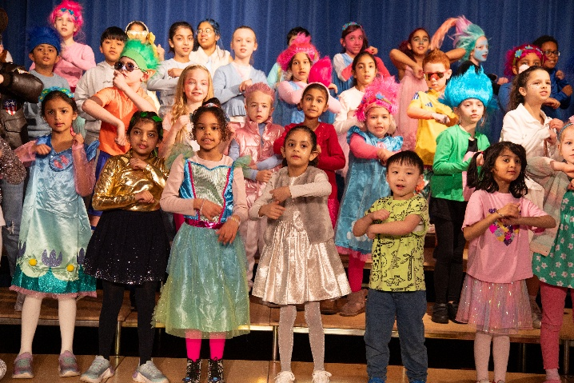

We are delighted to confirm the website Galery is now ready to view all the photographs from this special event. To view the gallery on our website please click here. The password to view the photographs is: PrimaryTrolls2026



Kick Boxing Orange Stripe Belt
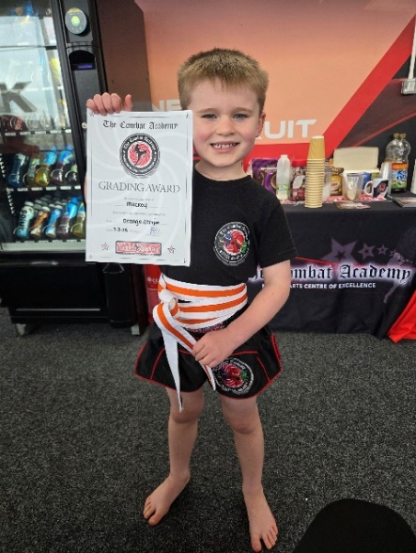
Congratulations to Mackey, Year 1, who was awarded his Orange Stripe belt in his Kick boxing. Well done, Mackey, keep up the hard work.

Lucia’s Football Weekend
Lucia, Year 4, enjoyed a memorable day of football on Saturday, beginning with Leicester City U9s in a special “international” style fixture against Wales U9s. The teams played two 40-minute matches, with Leicester winning both games.
After the matches, Lucia quickly travelled up the M1 to Derby County’s home game against Sheffield Wednesday, where she had been invited to represent Derby County Women as part of the club’s International Women’s Day celebrations. Lucia and her teammates took part in the pre-match flag bearing and later completed a lap of honour at half-time, receiving applause from the crowd of more than 30,000 fans.
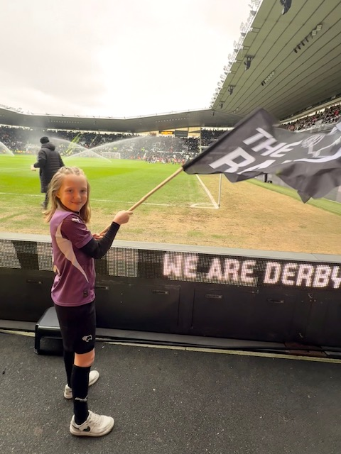
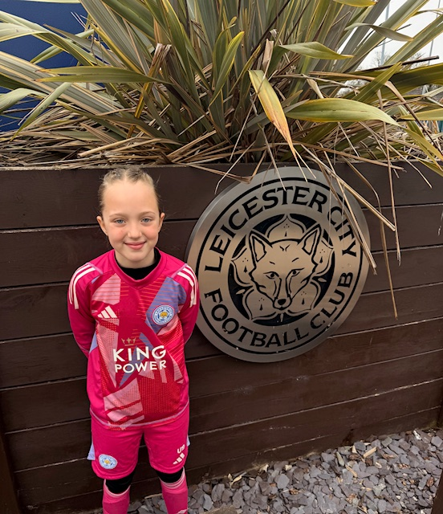

Dance Festival
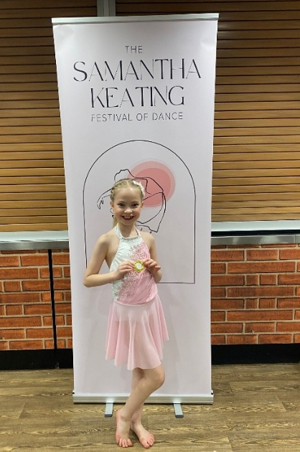
Congratulations to Berenice, Year 4, who competed in a dance festival last weekend. Berenice performed a Lyrical dance for the first time. Congratulations Berenice on your awards you received on the weekend.

Nellie’s Gymnastics Success
Congratulations to Nellie in Reception. Last weekend Nellie was awarded her Level 1 – Blue Award in Gymnastics. What a fantastic achievement, Nellie. Keep up the hard work
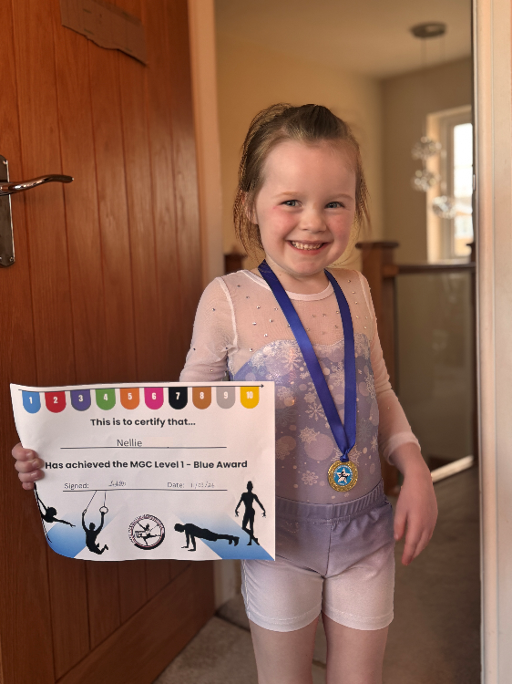

Josh’s Dancing Awards
Last Weekend, Josh, Year 5, had a very successful time at the Tiptoe Presentation Evening. Josh was delighted to win awards for Ballet, Tap, Modern, Street and Acro. Josh was also awarded the ‘Zest of Life’ award - which is a valued award within Tiptoe Performing arts. Congratulations Josh!
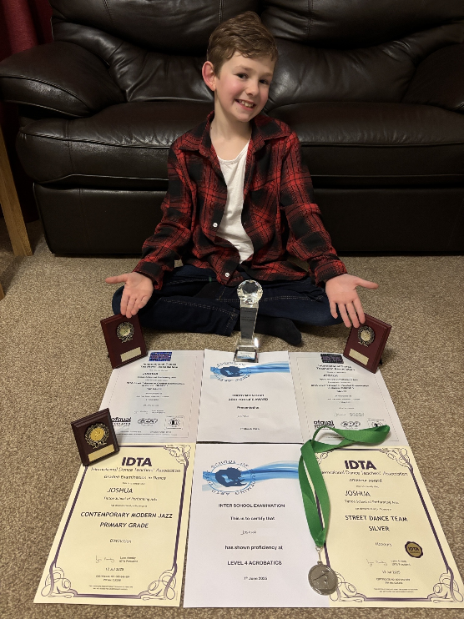

Hockey Success
Mia, Year 5, enjoyed a successful day in the U10 Girls Derbyshire County Club Qualifiers against Belper.
Playing for Repton, Mia scored once and provided an assist in a 4–1 victory, earning Player of the Match as voted by the opposition team. The win means Repton have qualified for the Midlands Area Championships later this month.
Repton also played a friendly against a mixed Belper/Ashbourne team, winning 6–1. Mia contributed with a goal and an assist, proving a constant threat from the heart of midfield in both games. Well done, Mia!
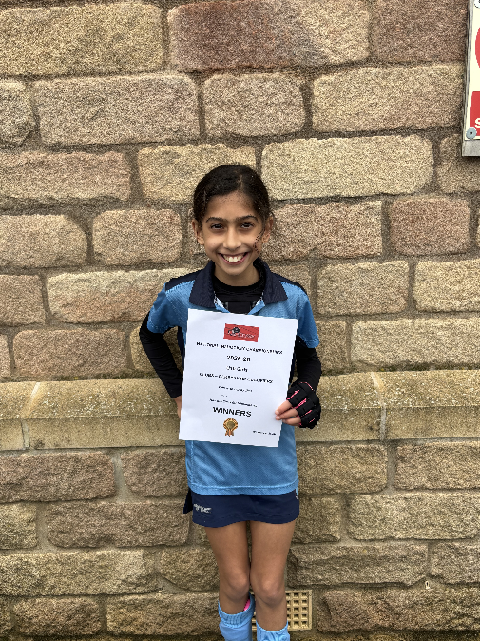

LAST CHANCE TO VOTE, voting closes 9am 18th March - Please Support Mrs E
You may recall that last term we asked for your support in voting for Mrs E in the Lots for Tots Awards. We are delighted to share that she has now been shortlisted as a finalist in the category Early Years Educator of the Year.
Public voting closes 9am Wednesday 18th March and every vote truly counts. If you previously voted to help Mrs E reach the shortlist, we would be very grateful for your continued support as we now aim for the final stage — winning the award.
You can view a short video explaining what this recognition would mean to Mrs E here: CLICK HERE
To vote, please select Dora Eleftheriou under Early Years Educator of the Year at the following link: Vote - Lots for Tots
Thank you for your support!
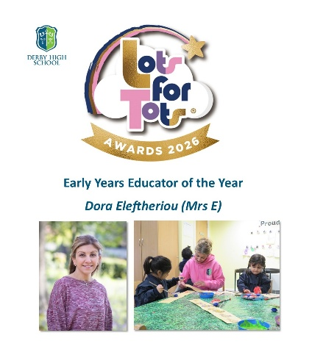
Easter Tennis Camp
Woodlands Tennis Club is proud to announce that their Easter Holiday Camps will take place on the following weeks:
Tuesday 31st March - Thursday 2nd April
Tuesday 7th April - Thursday 9th April
Please note that this is not ran by Derby High School
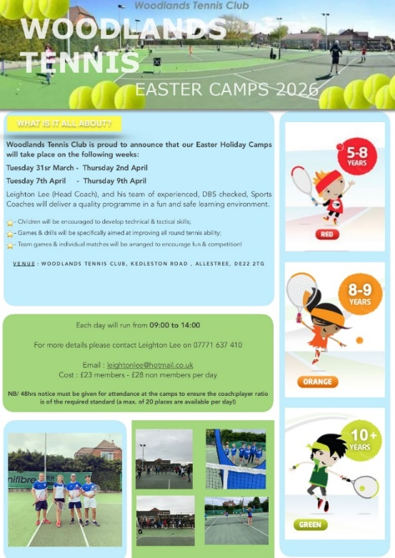


Safeguarding Podcast Episode 62 - Safe and Sound
This week Mrs Bellman (Deputy Head - Pastoral, DSL) welcomes two guests onto our weekly safeguarding podcast. Sheila and Ali from Safe and Sound join Mrs Bellman to talk about the important workshops they have been running in our school with Year 7. Safe and Sound work with young people in Derbyshire and are passionate that every child should live a life without exploitation.
To listen to the podcast on Spotify, please click here.
For more information on Safe and Sound please follow this link: Home - SAFE AND SOUND
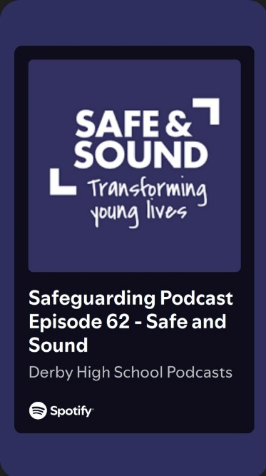
When School Feels Impossible – Webinar
This webinar is for parents, carers, teachers, TAs, SENCOs, and anyone supporting a child who is struggling to attend school. We'll look at what's really driving school avoidance, how to break the shame cycle for everyone involved, and how to recognise progress that doesn't show up on a register.
​For more information please click the following link: Book your place here​
With both parents and educators in the room, there'll be space for honest conversation across the home-school divide.
Date: Wednesday 25th March 2026
​Time: 7pm GMT
​Duration: 90 minutes (45 mins taught, 45 mins Q&A)
​Platform: Live on Zoom ​
Cost: £20

Monday 16th March – Reception trip to Rosliston Forestry Centre
Wednesday 18th March -Year 2 trip to Dudley Zoo
Thursday 19th March – Learning Reviews (in person)
Friday 20th March – Year 2 Thrushes Assembly
Monday 23rd March – Learning Reviews (online)
Monday 23rd March – ABRSM Exams
Tuesday 24th March – ABRSM Exams
Tuesday 24th March – Primary Spring Concert
Wednesday 25th March – Year 3 residential trip (Departs)
Thursday 26th March - Year 3 residential trip (Returns)
Thursday 26th March – Year 1 Lion Learners animal experience
Friday 27th March – End of Term, No PET or Late Waiting


